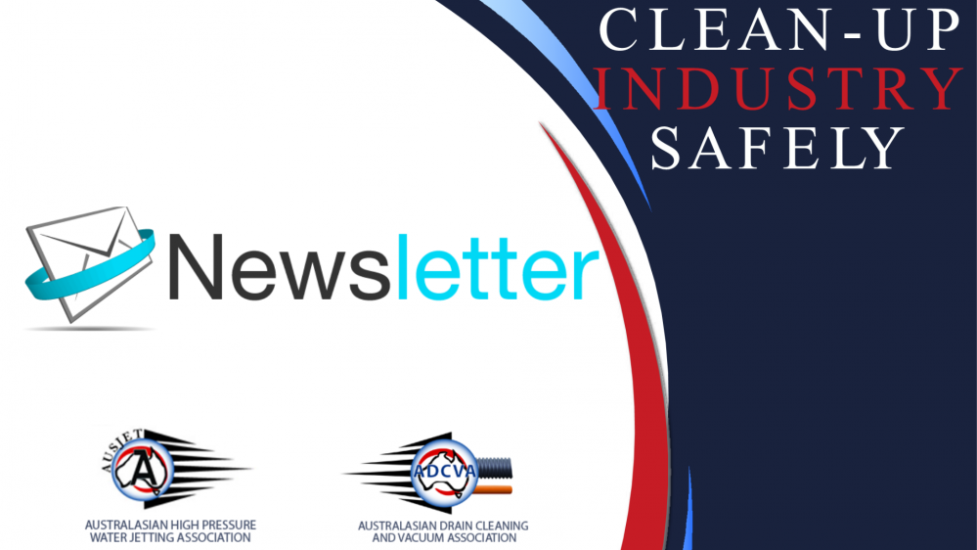

AUSJET/ADCVA Newsletter

August 2023

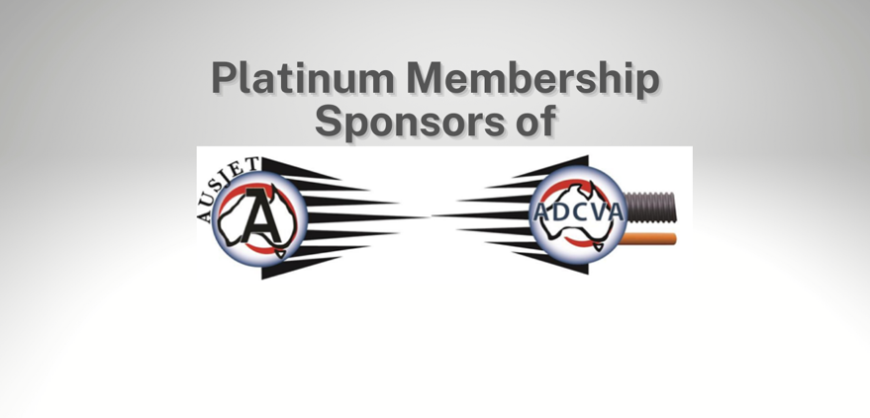
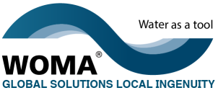

Chairperson's Report
The previous 12 months have been a successful year for the organization, in large part of it has been through the involvement of the members participating in the various projects.
It all started with the inaugural Ausjet22 conference, which was a hugely successful week and I thank everyone for their participation and enthusiasm.
On behalf of the board, I wish to extend my thanks to the Ausjet22 sponsors, Hammelmann, KOR, Cleanaway, Blastone, Aqua Prep and TRHC, and our official Media Partner, Trenchless Australasia, exhibitors, and panel members. Without everyone’s contribution and support the conference would not have been the success it was. As we look forward to AUSJET24 in only 12 short months there are still sponsorship positions available and if anyone has any topics for discussion, they think are relevant for our industry please reach out to myself.
AUSJET/ADCVA proposed NDD study is underway, the organisation is working with La Trobe University to study the services offered by members of AUSJET/ADCVA and produce educational material to inform and educate the construction industry, local government, and universities of the multiple economic and environmental benefits of the emerging hydro jet excavation industry. Board Member Rod Purtill is leading this project and has provided a detailed update further on in the newsletter.
Peter Jones is leading a sub-committee to do a review of AS4233:2013 High Pressure Water Jetting Systems. Due to some scheduling difficulties with the sub-committee, we will be hard pressed to meet the completion timetable of 2023, thus this project may flow into 2024.
A lot of members are taking advantage of the online Class A training, we are seeing registration numbers for the training increase significantly over the past six months. Thanks to the hard work from Gabe Wardle, the online training is now very user friendly, and certificates are issued at the completion of training.
The Safety Forum is established, a revised charter has been sent out to all participants. The objective of the Forum is to bring together Health & Safety leaders across the industrial service industry, in order to share incidents and learnings, so that participants can drive down injury rates and reduce risks.
Please do follow us on social media, sign up to our newsletter, and get involved in our projects. We are making sure that there is the chance for everyone to be a part of this inspiring and welcoming organisation, I urge you to take these opportunities and get involved.

Stay Safe.
Lance McKay
AUSJET / ADCVA Chairperson

DEN-JET Australia - Platinum Member and Sponsor of AUSJET/ADCVA

DEN-JET is a leading supplier of Water Blasters, Water Jetting Accessories, Safety Equipment, Spare Parts, and Rental machines. The OEM business manufactures High-Pressure Water Blasting Machines and accessories for many applications such as Decommissioning, Industrial & Marine Cleaning, Concrete Demolition, Surface Preparation, Mining amongst many other functions. The company has a reputation for specialist knowledge, quality products with a safety focus, competitive prices, and excellence in customer service.
The Den-Jet CD160 series & CD50 Water Blaster has a few extra accessories available now for customers. Introducing a canopy cover in either Stainless Steel or Galvanise material, which offers good protection of the asset and great display for company logo. Gas struts to lift canopy doors and safety bar to prop door open. Easy access to all vital engine and pump components.
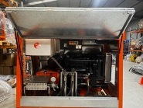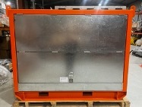
The CD160 can operate at a maximum of 36,000 psi @ 25 ltr/min with special rotating nozzles. It has a stainless-steel pump-head with an electronic engine controller, feed pump and turbo charged 4- & 6-cylinder engines. The CD160 models are powered by Argo Power aka. Massey Feguson engine. The pump can also be set up as CD160-1400 operating at 20000 psi @ 40 ltr/min. A great pump for concrete demolition and general surface prep. Available now with standard and optional accessories.
The CD50 series is popular due to its flexibility of pressure and flow with combinations ranging from 230bar to a maximum of 2000bar. The CD50 model is powered by genuine 50Hp Toyota diesel engine and there are 7 powerful models in the range. The CD50 Water Blaster is user-friendly, cost effective and with a very small footprint. Each machine comes with standard accessories such as 20m HP hose, dump gun and Fan/Pin nozzles, and optional Rotating nozzle with 4 Sapphire Jets. Many applications such as corrosion control, surface preparation, underwater blasting, and oil well pressure testing is well suited for this high-powered pump.
DEN-JET can help configure the equipment you need for a safe and successful job with the knowledge of working with the best products and expertise that your project demands.

Den-Jet Australia Pty Ltd
24-28 Bowyer Road, Wingfield SA 5013
E: au.sales@denjet.com
P: +61 439 118 776
W: www.denjet.com.au
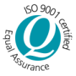

WOMA Australia - Platinum Member and Sponsor of AUSJET/ADCVA

WOMA Australia Pty Ltd

WA
16 Redemptora Road, Henderson, WA 6166
hpwater@woma.com.au
08 9434 6622
www.woma.com.au

Non-Destructive Digging (NDD) Study
At the recent AGM a vote was put to our members about AUSJET/ADCVA partnering with the La Trobe University to conduct a study of the services offered by members of AUSJET/ADCVA and produce educational material to inform and educate the construction industry, local government, and universities of the multiple economic and environmental benefits of the emerging hydro excavation industry.
I’m happy to announce that the vote was successful and the partnership with La Trobe University for this study will go ahead.
Investment wise this is one of the largest projects that AUSJET/ADCVA has undertaken for this study to happen. The members present at the AGM and the board were unanimous in the decision to invest into something this important, that will add benefit to our members long into the future.
From member engagement the main challenge members of AUSJET/ADCVA face is communicating that, despite the higher short-term running costs of high-velocity water jets, the long term running cost savings to infrastructure maintenance far exceed the short term costs.
Educational materials will include:
- Whitepaper studies,
- Marketing materials,
- Learning materials,
- Videos,
- Other teaching materials.
The Strategic Objectives of this study are:
Creation of various education and marketing materials to inform and educate potential future stakeholders and potential customers of the economic benefits of Hydro Excavation technology. This includes:
- Transfer of information from AUSJET/ADCVA and their members to La Trobe University project members. The information pertains to the actual and perceived economic benefits of highvelocity water excavation technology relative to historically applied solutions.
- Inform and educate excavators, construction companies, local government and other users of conventional technology of the economic benefits of highvelocity water jet technology (and the newer applications of the technology) relative to other solutions.
- Inform and educate current stakeholders and potential future stakeholders (who are not familiar with the technology) of the history, technology and current application of highvelocity water jet technology and the benefits of its application.
- Inform and educate the current academic and student cohort about the current state of highvelocity technology in the construction industry and the economic benefits of its application.
- Analyse the economic benefit and business value of implementing the technology solution across all different potential use cases, in the construction industry, local government projects and other potential uses.
- Build momentum for the future of high pressure water and vacuum systems for applications in other industries, such as mining, through the application of Artificial Intelligence.
We will be calling for expressions of interest (EOI) from our members to join a sub-committee on this study, it is a great opportunity to be involved in a project that will drive the NDD industry into the future.
The sub-committee will be led by previous board member Rod Purtill, the current board are excited to have this project started.
If you have any questions regarding joining the sub-committee, please reach out to Gabe at AUSJET/ADCVA and she will be able to help with any queries.
Regards
Lance McKay
AUSJET/ADCVA Chairperson

Board of Management 2023-2024
Group 2 of the Board of Management positions (4) were declared vacant (as per the Constitution) at the AGM held in Victoria on Friday 25th August 2023.
Six (6) nominations for the Management Committee were received and those nominations were:
- Peter Jones – KOR Equipment Solutions
- Gerry Murphy – WOMA Australia Pty Ltd
- Peter Nicholas – Veolia Environmental Services
- Randolph Briggs – StoneAge Inc
- Andrew Gladman – Spoutvac a BUCHER Company
- Mitchell Cleary – The Austrans Group
Voting took place prior to the AGM by a representative of each member company.
Voting commenced 12 noon 10 August 2023 and closed 5pm Monday 21 August 2023
Votes were received from 24 out of 99 member companies.
The four (4) nominations who received the most votes were:
- Andrew Gladman – Spoutvac a BUCHER Company
- Peter Jones – KOR Equipment Solutions
- Peter Nicholas – Veolia Environmental Services
- Gerry Murphy – WOMA Australia Pty Ltd
The first Board meeting for the 2023-2024 Board of Management was held on Thursday 7th September 2023. At this meeting a vote was held for Office Bearers.
Results were:
- Chairperson - Lance McKay
- Treasurer - Gerry Murphy
- Secretary - Gabe Wardle
Please meet the AUSJET/ADCVA Board of Management for 2023-2024
 | LANCE McKAY  FIRMUS Group | Director/Chairperson | lmckay@firmusgroup.com.au  0408 758 640
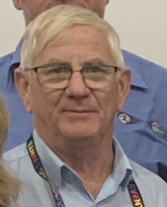 | GERRY MURPHY  WOMA Australia Pty Ltd | Director/Treasurer | gmurphy@woma.com.au  0477 500 051
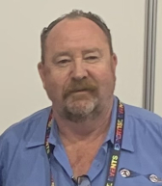 | PETER JONES  KOR Equipment Solutions Pty Ltd | Director/Vice Chairperson | pjones@kor.com.au  0429 005 644
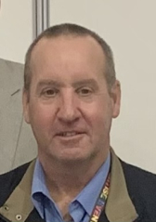 | PETER NICHOLAS  Veolia Environmental Services | Director | peter.nicholas@veolia.com  0427 277 503
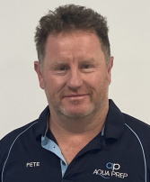 | PETER BRADFORD  Aqua Prep | Director | peter@aquaprep.com.au  0468 388 751
 | CHRIS BROOKSBY  McMahon Services Australia | Director | christopher.brooksby@mcmservices.com.au  0429 494 788
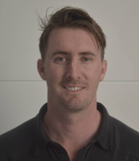 | ANDREW GLADMAN  Spoutvac a BUCHER Company | Director | andrew.gladman@buchermunicipal.com.au  0413 442 550

Rodney Purtill did not stand for a position on the Board for this financial year. We would like to thank Rod for his contribution to the Board of Management since he was voted in on the 16th August 2018.
We would also like to thank and congratulate Rod for his hard and comprehensive work given to the Hydro Excavation Study. Rod will be heading up the Sub-Committee for this project going forward.

AGM Event

Since undertaking a survey with our members, and collating their responses, AUSJET/ADCVA have held the AGM at a location where there can be a function/activity held that is perfect for networking and an opportunity to bring partners/family.
The recent AGM was held in The Mornington Peninsula Victoria at the Moonah Links Resort, where the AGM function was a Golf Competition on Thursday 24th and the General Meeting and AGM being held on Friday 25th.
The Golf Day was a great success. Commencing at 10.30 on a brisk but sunny Victorian morning and wrapping up around 2.30pm. After listening to some of the stories about slices (not cake), divots, sand traps and pesky trees, I believe the sunburn and lack of math skills didn't get in the way of a good time and networking with good people.
Thank you to everyone who participated and we look forward to the next AGM Event!

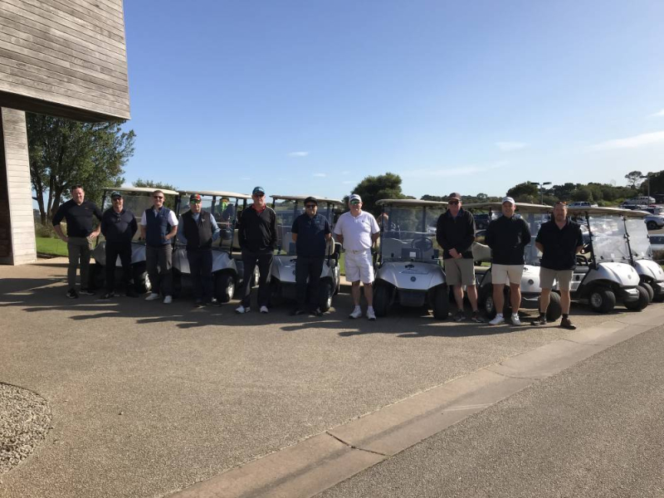

Safe Work Australia

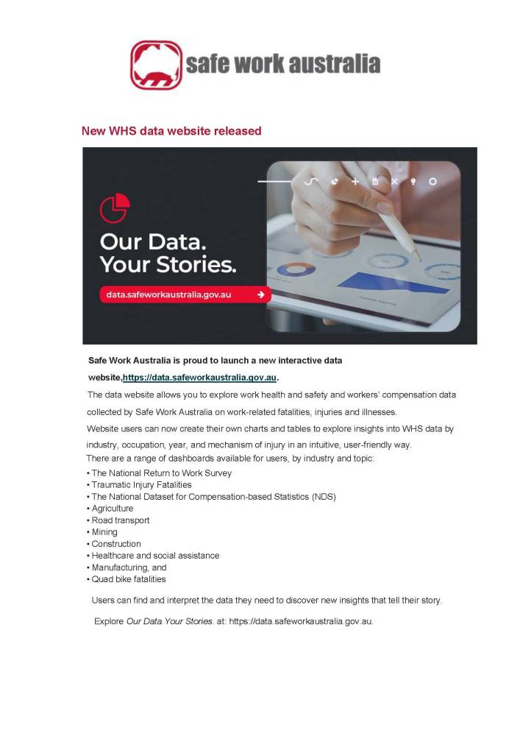

Class A Training

Class A training relates to the use of high pressure water pumps under 5600 bar litres per minute as defined by Section 1.1 of AS4233:2013.
AUSJET's Online Class A Training meets the requirements set out in Section 7.2 of AS4233:2013 Part 1.

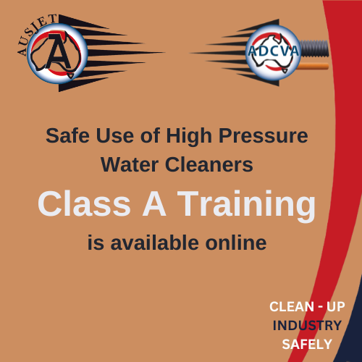

Follow this link to access the Class A Training
https://www.ausjetinc.com.au/training/class-a-training/

Save money on training - become a member.
AUSJET and ADCVA exists to strengthen safety standards for business and industry working in the Water Jetting, Drain Cleaning, Vacuum Loading and Hydro Excavation Industries.
Becoming an AUSJET / ADCVA member provides opportunities to be a part of a proactive and innovative network that promotes capability and capacity of our members and provides a strong network of member companies and businesses seeking to provide a safe work environment through improved standards, training and advocacy.
To become a member go to www.ausjetinc.com.au/membership/ procedures-for-new-member
www.ausjetinc.com.au
0430 391 166

New Members

AUSJET/ADCVA welcomes new member

Brokk Australia Pty Ltd

Based in

South Australia

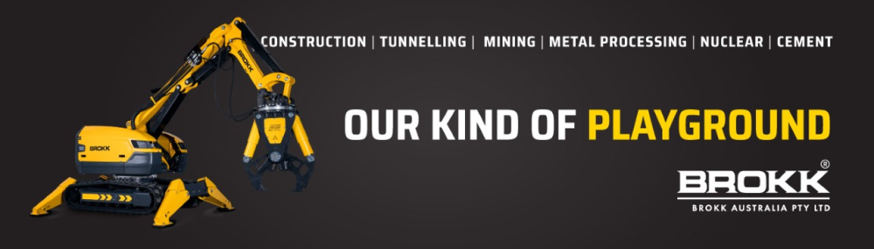

Brokk Australia is a subsidiary of Brokk AB and part of the Brokk Group of companies. The Brokk Group is a world leader in specialised and technically advanced demolition equipment for various industries, including mining, tunnelling, construction, nuclear, cement and process. The group consists of several market-leading product and sales companies worldwide. Brokk is a wholly-owned subsidiary of the international investment company Lifco Group.
Headquartered in Adelaide, with multiple service locations around Australia, Brokk Australia has a fully equipped workshop capabilities and experienced after-sales support, including service technicians, training and spare parts. Brokk is the leading supplier of remote-controlled demolition robots worldwide. With over 40 years of innovation, Brokk has earned global recognition for its demolition robots and countless attachments, which continue to provide safe, efficient and powerful demolition solutions.
We are excited to announce that Brokk Australia is now distributing Aquajet products to the Australian market. Aquajet is designed to revolutionise the way you remove concrete and other materials from surfaces, providing a powerful and efficient hydrodemolition system for your business. Aquajet has been meticulously crafted to provide superior performance, durability, and convenience. With its state-of-the-art technology, this product is perfect for businesses looking for a hydrodemolition solution that is effective, efficient, and safe.
Features include:
- High Water Pressure: Aquajet provides a high-pressure water jet that effectively removes concrete and other materials from surfaces without causing damage to surrounding areas.
- Precise Control: With Aquajet, you have precise control over the water pressure and flow, allowing you to target specific areas with accuracy and ease.
- Environmentally Friendly: Aquajet uses only water as its main ingredient, making it an eco-friendly alternative to traditional demolition methods that rely on chemicals or other harmful substances.
- Easy Site access: With a compact design, this product is easy to install and can fit into small spaces, giving you the ability to access even the smallest of sites.
Whether you are working in construction, maintenance, or any other industry that requires demolition with precise control, Aquajet provides a great alternative to your demolition needs.
To learn more about Brokk Australia Pty Ltd visit their website www.brokk.com/au
email stefan@brokk.com.au
or phone 08 8387 7742

AUSJET/ADCVA welcomes new member

Avcon Projects Australasia Pty Ltd

Based in

New South Wales

Avcon Projects Australasia is a leading industrial service, emergency and environmental response company that specialises in providing rapid, effective and sustainable solutions to mitigate asset liabilities and respond to emergencies, natural disasters and environmental incidents.
At Avcon, we take pride in delivering the best project and hazardous materials management solutions available in the market.
Industrial services are highly dependent on the specific site, needs, and complexities of our clients. Our industrial service jobs primarily focus on hazardous materials, dangerous goods, complex engineering considerations, and hazardous environments.

Want to learn more about Avcon Projects Australasia Pty Ltd? Go to www.avconprojects.com.au
Email contacts@avconprojects.com.au
Phone 1800 736 681

AUSJET/ADCVA welcomes new member

USB-Australia Pty Ltd

Based in

Victoria

USB AUS is a subsidiary of the company USBD SEN (Germany), founded in 1989.
We are a manufacturer and supplier of sewer and pipe cleaning nozzles, root cutters and special products. Our products, are all made of stainless steel and are distinguished by their high processing quality, as well as their high cleaning performance and traction in everyday operation.
USB Australia is the proud partner for IBAK Australia. IBAK designs and produces high-quality sewer inspection and rehabilitation solutions for worldwide use. In this way, we have been making a significant contribution to the progress of the sewer industry for over 75 years.
As a reliable partner, we help our customers to ensure the functionality of their sewer systems. For a clean environment and a secure supply.

Want to learn more about USB-AUS? Go to www.usbaus.com.au
Email shannon@usbaus.com.au
Phone 0421 821 765

AUSJET/ADCVA welcomes new member

TST Sweden AB

Based in

Sweden

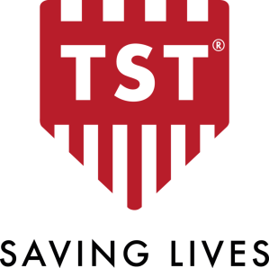

Founded in 1990, today TST Sweden is one of the world's leading companies in personal protective equipment (PPE) for extreme work environments.
We offer protection for:
- Waterjetting up to 3 000 bar / 43 500 psi
- High pressure cleaning up to 500 bar / 7 500 psi
- Workplaces up to 3 000 bar / 43 500 psi
- Radiant heat and molten metal
- Cooling vests
To ensure the highest quality, safety, and functionality, we develop our products in close cooperation with end users around the world – every single product is born out of necessity. We develop our products ourselves and the production is local, which allows us to better control the entire chain. All of our personal protective equipment is CE certified, which means our products meet EU’s safety, health or environmental requirements.

Over the years, we have developed a culture of continuous innovation, where methods, concepts, and products are developed and refined on an ongoing basis. We have evolved into an innovative business partner who, through impeccable service and expertise, makes personal protective equipment smarter and the world a little safer. With our promise “saving lives” we continuously work to make sure that our customers come home to their families and loved ones, every day.

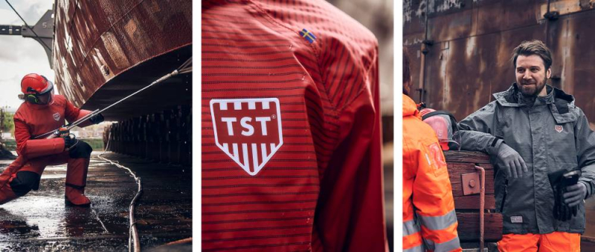

Learn more at www.tst-sweden.com
E-mail: info@tst-sweden.se
Phone: +46 320 20 58 80

Incident Reporting

One of the responsibilities of being a member of AUSJET/ADCVA is to report all incidents. It is important we communicate all incidents within our industry to prevent them from reoccurring and to improve industry safety both here in Australia and now globally through the GICC Global Industrial Cleaning Coalition.
All information is kept strictly confidential and can be reported through our website safety/report-an-incident-/, or directly to our administrator Gabe Wardle support@ausjetinc.com.au. In all cases we request the contact details of the person reporting the incident, so we can work with them to develop an industry safety alert.
When developing the industry safety alerts any reference to the company that had the incident, or the location of the incident is removed. Prior to publishing the safety alert, we send a draft of the alert to the reporting person for their approval prior to distributing the alert to our members and on social media.

What should be reported?
To truly improve industry safety, we would like to see all incidents involving High Pressure Water Jetting, Vacuum Loading, Drain Cleaning and Hydro Excavation reported including:
- Accidents
- Injuries
- Near Misses
- Environmental Incident
In some circumstances we understand that some incidents may be placed under legal privilege. In these instances if possible we would request that members simply advise AUSJET/ADCVA that an incident has occurred without specific detail, then at the completion of the investigation and the period of privilege, we can then work together to develop a safety alert.

To report an Incident, please go to safety/report-an-incident-/

Prioritising Safety in Construction
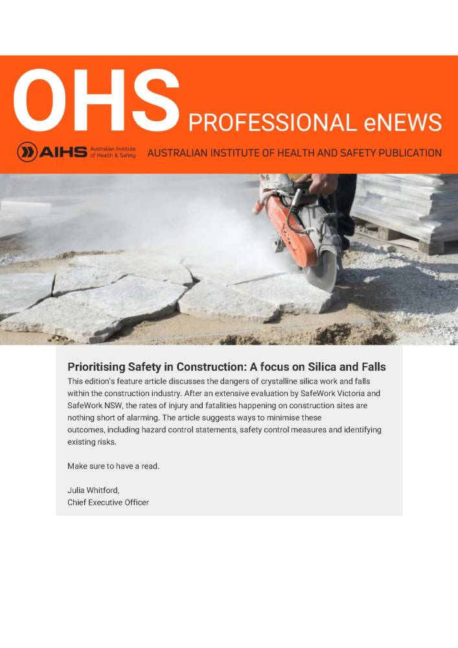

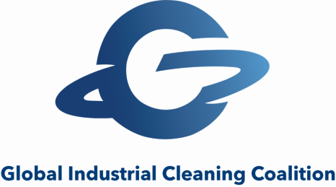

Collaborative Development and Promotion of Basic Industrial Cleaning Principles

The Global Industrial Cleaning Coalition (GICC) is a group of industrial cleaning safety associations, asset owners, contractors, and equipment manufacturers voluntarily coming together to contribute to the creation and adoption of basic industrial cleaning principles around the world.
Our mission is to help national safety associations adopt basic principles in high pressure water jetting, municipal/vacuum truck cleaning, chemical cleaning, and respiratory protection that are easy to implement country by country in consideration of differing workforce, regulatory and economic conditions and without imposing on sovereignty of the existing national organizations.
The purpose of the GICC is to help save lives and reduce injuries in the industrial cleaning industry through the collaborative development and promotion of basic industrial cleaning principles.
“There is no need for unnecessary injures or work-related deaths. Be part of a global shift in mindset that will help save lives.”
Kerry Siggins, CEO, StoneAge, Inc.

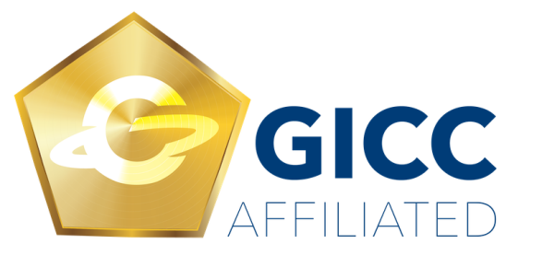

Show your support by featuring the GICC badge on your website. Please link to our website to help spread the word about this movement and your affiliation with it.

For more information about the GICC, please visit their website at https://www.globalindustrialcleaningcoalition.org/

Publications Available to Purchase

Recommended Practices for the Use of Industrial Vacuum Equipment Booklet - First Edition 2020
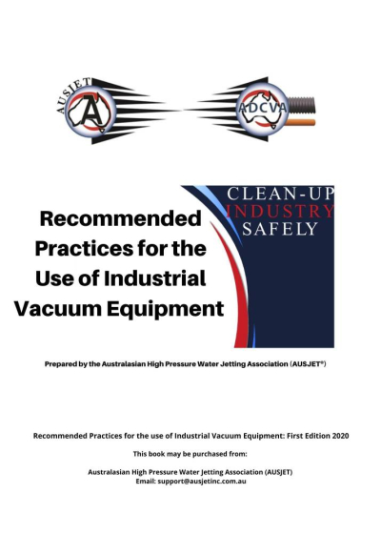

For more information, or to purchase a copy, see Merchandise page or please contact support@ausjetinc.com.au

Recommended Practices for the Use of Industrial Drain Cleaning Equipment Booklet - First Edition 2022

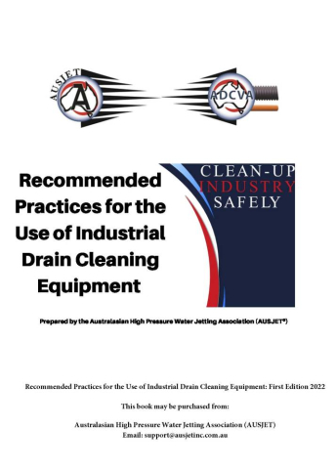

For more information, or to purchase a copy, see Merchandise page or please contact support@ausjetinc.com.au

AUSJET / ADCVA Meetings

General Meeting, Annual General Meeting and AGM Event - Thursday 24th and Friday 25th August 2023
This meeting and event were held at Peppers Moonah Links Resort, Victoria.

General Meeting - Thursday 2nd November 2023 @ 2pm AEDT
This meeting is scheduled to be held in Newcastle, NSW.
Further details to be advised.

If you would like to host this meeting, please get in touch with Gabe at support@ausjetinc.com.au

Newsletter and Website Advertising

The AUSJET / ADCVA Newsletter is an e-newsletter which is distributed via email across the membership and other Industry groups and individuals throughout Australasia and internationally; as well as the AUSJET website and across Facebook and LinkedIn social media platforms.
Advertising in the Newsletter consists of either an image advertorial and/or an article advertorial which allows your business to get noticed by those with influence in the Water Jetting, Drain Cleaning, Vacuum Loading and Hydro Excavation industries.
The Newsletter is distributed bi-monthly: February, April, June, August, October, and End of Year December.

Newsletter - Advertise your business and services in the next Newsletter.

Item | Platinum Member | Member | Non-Member
Newsletter | FREE  As per Platinum Member Benefit | $199.00 per Advertorial  OR  $150.00 ea for four and get two FREE  $600.00 annually | $220.00 per Advertorial

Web Banner - We encourage members to advertise on the AUSJET / ADCVA website (Web Banner) which is displayed at the bottom of this screen and across every page. The AUSJET / ADCVA website is accessed by members, industry, government, and the community.

Item | Member | Non-Member
Web Banner | $380.50 Financial Yearly | (Members Only Benefit)

If you would like to advertise in the newsletter or on the webpage, please email: support@ausjetinc.com.au

Merchandise

Item | Description | Price | Buy Now
Recommended Practices for the Use of Industrial Drain Cleaning Equipment Booklet  First Edition 2022  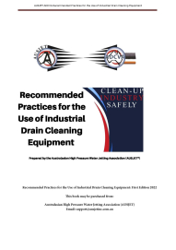 | The Australian first edition of the Recommended Practices for the use of Industrial Drain Cleaning Equipment  Prepared by the Australasian High Pressure Water Jetting Association (AUSJET*)  Members  1 - 10 books $19.80ea  10 books & above $16.50ea  Non-Members  1 - 10 books $27.50  10 books & above $24.20 | Members  $19.80  Non-Members  $27.50 | Contact: support@ausjetinc.com.au
Recommended Practices for the Use of Industrial Vacuum Equipment Booklet  First Edition 2020  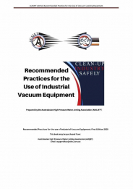 | The Australian first edition of the Recommended Practices for the use of Industrial Vacuum Equipment  Prepared by the Australasian High Pressure Water Jetting Association (AUSJET*)  Members  1 - 10 books $19.80ea  10 books & above $16.50ea  Non-Members  1 - 10 books $27.50  10 books & above $24.20 | Members  $19.80  Non-Members  $27.50 | Contact: support@ausjetinc.com.au
Guideline notes for safe use of a High Pressure Water Jetter | To download a copy of the guide, go to Safe Work Australia website: Safe Work Australia
Australian Standard AS4223 1 & 2 | To purchase AS4233 1&2 go to Standards Australia website: Standards Australia
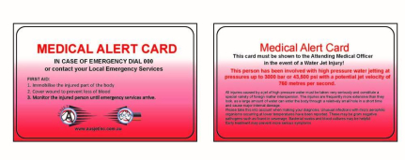 | AUSJET Medical Alert Card (wallet size) | $2.50 each | Contact: support@ausjetinc.com.au

